WHS Career Pathway in Music
Instrumental Music

In order to receive an Instrumental Music Career Pathway Cord, you must have been enrolled in band for all four years and have taken at least one additional music class:
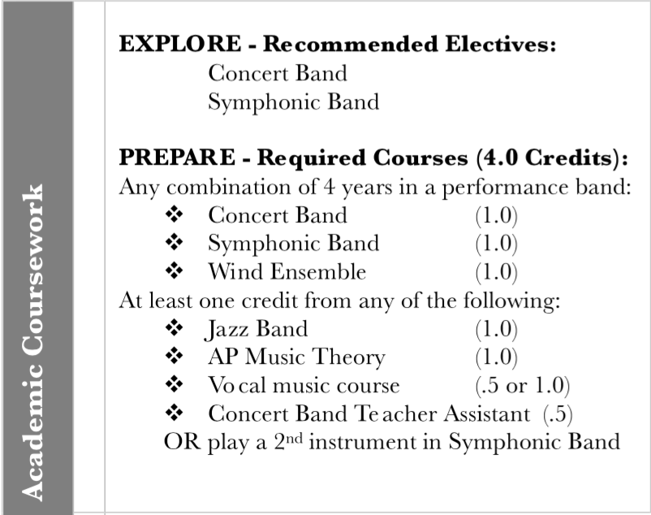

In addition, you need to document 60 hours of extra-curricular work (marching band, private lessons, helping at the middle school, etc.)

The final paper must be grammatically correct, neatly typed and presented in order. Items 1, 2 & 3 may be mostly lists or a neatly organized table. When documenting extracurricular hours, give contact information for an adult that can confirm your work and hours. Items 3-7 should be well written, succinct paragraphs. Document and write short reflections on the following:

- List music course work, e.g. band/choir classes, music theory, accompanying, assistant conducting, musical theatre, etc. Your name, school, school address and years attending the school should be part of the heading for this page.

- Provide a music resume that includes performance history beyond course expectation: honor groups, solo/ensemble contest, NATS, other ensembles. You can get resume guidelines online or in the Career Center.

- List your music extracurricular activities – document 60 hours (internships, mentorships, job shadows, private lessons, related community projects & service, school musical). Provide a signature if you helped a certain teacher.

- Write a succinct paragraph on how you have demonstrated leadership through your music classes e.g. plan, organize, conduct, initiate and complete tasks, be dependable.

- Write a succinct paragraph on how you have demonstrated problem solving through your music classes, e.g. identify problems, consider solutions, carry out appropriate action.

- How have your music classes helped increase your communication skills? Give at least two examples. (can you communicate clearly and effectively, listen to others, respond appropriately?)

- How have your music classes made you a team player? Teamwork – the ability to work productively with others, negotiate, build consensus, share decision-making, manage conflict. Give a few examples.

- How have your music classes helped you in your planning for educational and career goals (not necessarily in music)? Examples could include time management, communication, the ability to assess behavior, organization, etc.

- Write three different music critiques:

- Write a performance critique of an ensemble in which you participated. This is essentially a concert reflection of the ensemble you are in.
- Write a rehearsal critique of an ensemble in which you participated. Give examples of what was worked on, order of events, critique from the director.
- Write a performance critique of different ensemble you observed at a school concert or professional band concert. The Oregon Symphony is also an acceptable ensemble.

Question 9 should be two, double-spaced pages. Include some literature research, e.g. title of piece, composer, arranger, historical era, genre, notable trivia, etc. Think of yourself as an art critic for The Oregonian newspaper writing for an audience, most of whom didn't go to the concert and are unfamiliar with the music. Write an engaging, descriptive critique that conveys your opinion and feelings about the music and the performing group.

First Draft is due by Friday, April 7. Draft needs to be handed in hard copy (please do not send a google doc or email attachment) Please have a friend or relative proof read your paper before you submit it.

Final Draft is due by Friday, April 14 – Hard Copy.

You will be notified if you receive the Career Pathway Cord the following week.

Questions? Email Danielle_davey@beaverton.k12.or.us or call (503) 356-3053.

Good luck!

